August 2021  In this Issue  - President’s Address  - Grants and Government Financial Support  - Metal Collection and BBQ Fundraiser  - Volunteering Opportunities  - September Fish Fry  - Mad God Kelly Bonspiel  - 2022 U Sports Championships and Mixed Doubles Championships  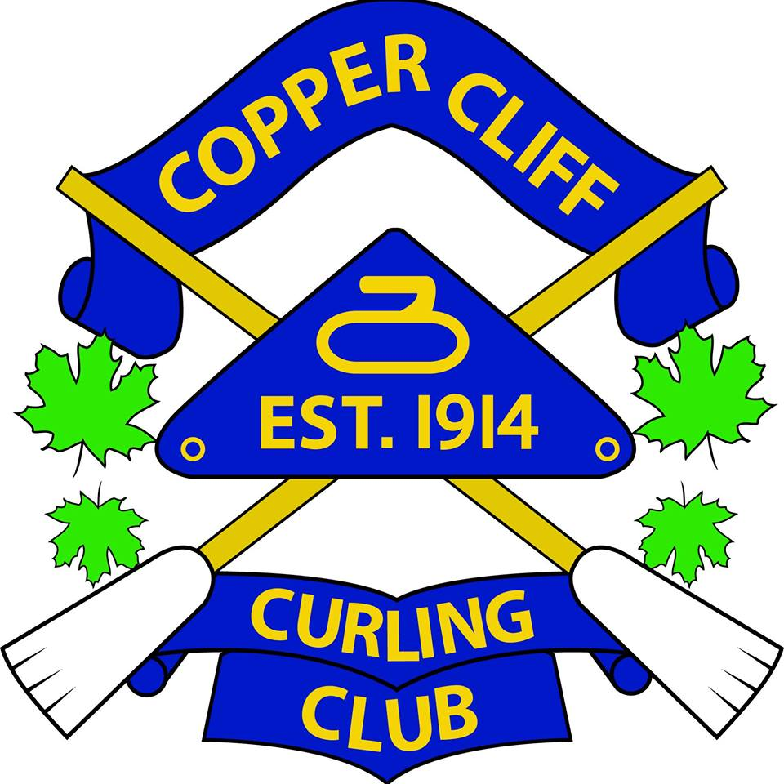 | Copper Cliff Curling Club  President’s Address  This past year has proven to be one of the most challenging in the history of Copper Cliff Curling Club. The onset of COVID-19 has impacted our membership, cash flow and our ability to offer curling on a scheduled basis.  We were fortunate to have even curled this past year as many clubs across the country had no curling played in their facilities this year. I am proud of your board of directors who have worked extremely hard to implement safety measures to salvage what we could of the 2020_21 curling season.  Even though COVID-19 greatly impacted our season it presented the club with an opportunity to learn a lot about the operation of our new plant and facility from a utility use perspective. The new plant is very efficient and only needed to operate on a very limited basis when we had to shut down. Also, measures were implemented so that very little water was used during this time resulting in considerable cost savings. Without the support of Ontario Trillium Foundation to buy new ice making equipment this would not have been possible.  Although we saved significantly in utility costs, I cannot express how appreciative I am of the substantial financial support received from the provincial Small Business Support Grant and the federal Covid Emergency Benefit Account. This funding has placed the club on a solid footing for the upcoming season.  Enjoy the following newsletter to bring you up to date on summer and fall activities, volunteering opportunities at our club and an exciting curling event to be held in Sudbury that our club is participating in.  I’d like to thank you, our dedicated membership, leagues, and our strong sponsorship for your ongoing and future support of Copper Cliff Curling Club. Let’s make our 2021_22 season one of the best yet!  Regards,  Tim Lloyd  President  Grants and Government Financial Support  A big “Thank You” goes out to the Ontario Trillium Foundation who has provided the funding ($109,500) for our new plant. The new plant will ensure that curling will continue to be played at our facility for many years into the future.  Copper Cliff Curling Club has been the recipient of Ontario Small Business Support Grants to help offset the cost of personal protective equipment, property taxes, energy bills and extra support. Starting at $10,000 for all eligible businesses, the grant provides businesses with funding to a maximum of $20,000 to help cover decreased revenue expected because of the Provincewide Shutdown.  We also received the Canada Emergency Business Account (CEBA) that provided an interest-free loan of $40000, $10,000 of which is forgivable if repaid by Dec 31, 2022. We have applied for a second CEBA loan of up to $20,000 – on top of the initial $40,000 that was available to small businesses of this additional financing, up to $10,000, will be forgivable if the loan is repaid by December 31, 2022. This funding is pending approval.  This support from the provincial and federal governments has allowed the club to operate through this difficult time.

Metal Collection and BBQ Fundraiser

A scrap metal and BBQ fund raising event will be hosted on Thursday August 19th. Donate your scrap metal to the club and enjoy sausages, hamburgers, and fresh cut fries. Keep an eye on our social medial pages for details.

Thanks goes out to the many sponsors participating in this event including Broker Link and Todd Pazant of Dominion Lending. A metal bin to place scrap items will be provided by Milman Industries and BM Metal Services. Sausages will be provided by Sunbeam Meats Butcher Shop 433 Laforest Avenue!

Take this opportunity to register for the 2021_22 curling season at this event. We are offering an early bird and new member rate of $399 for one night of curling and $599 for unlimited curling for adults. Full time University and College Students can curl on an unlimited basis for $199. Take advantage now before rates go up.

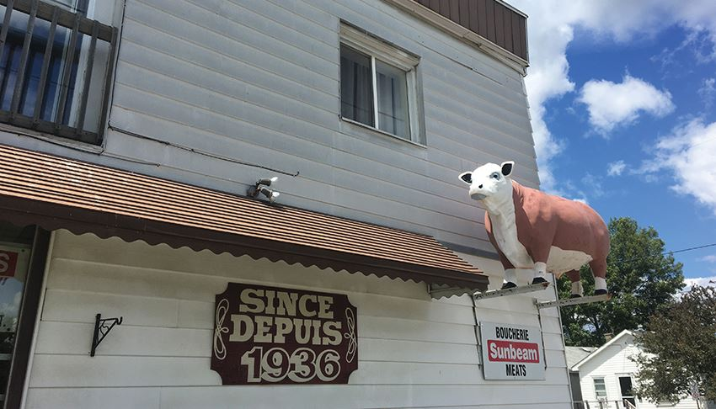

Volunteering Opportunities
Crews have been busy painting our plant room now that the cladding has been completed on our plant and new LED lighting has been installed (see before and after pictures).

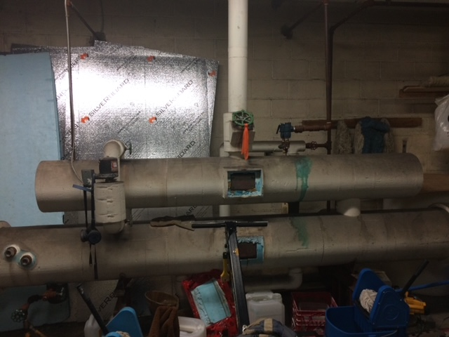
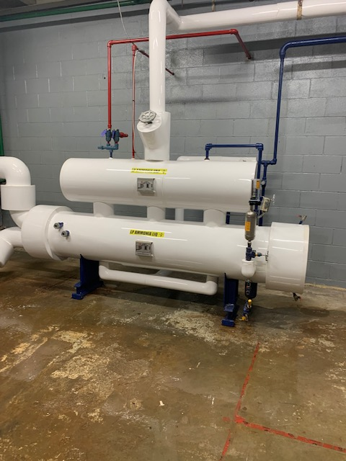

The exterior of your Copper Cliff Curling Club needs a little sprucing up! Crews will be painting the metal cladding on the front of the building during the second two weeks of September. Volunteers are always gladly welcomed as many hands make little work. Come out and pitch in to help make your club look great!
If you’d like to volunteer leave a message on the club’s answering machine at 705-682-4861 and someone will get back to you with times and details.

September Fish Fry
Our famous fish fry will be held on Thursday September 30, delicious Manitoulin whitefish will be served on a takeout only – first come first served basis – no pre-orders. There will be one- and two-piece dinners that includes a drink, coleslaw, and dessert. Come out and support your club. There will be 3 serving stations to get orders out quickly. Stay tuned for further details.
Mad Dog Kelly Bonspiel

Copper Cliff Curling Club
39 Veterans Rd. Box 867
Copper Cliff, On
P0M 1N0

705-682-4861
info@coppercliffcurling.com
coppercliffcurling.com

@coppercliffcurlingclub

@CliffCurling
In May we lost our very own John Kelly, a valued member and cornerstone of the Copper Cliff Curling Club. John was a colourful character and will be greatly missed by all that knew him. In honour of John’s many contributions to the club we will be hosting a bonspiel in his honour. The first annual Mad Dog Kelly Bonspiel will be held early in the curling season. It is anticipated that this will be a well-attended event so be sure to register early. Further details will be communicated soon.

2022 U Sports Championships and Mixed Doubles Championships
August 4th, 2021 In what is truly something of a historic collaboration, the Coniston Curling Club, the Copper Cliff Curling Club and Curl Sudbury will join forces, in a partnership with both the City of Greater Sudbury and Curling Canada to offer an incredible two week stretch of curling in March of 2022.

Fresh off the heels of the 2022 Olympic Winter Games in Beijing, China, Sudbury will welcome the best curlers in Canada as well as our next generation of curling stars to the Gerry McCrory Countryside Sports Complex, March 15th to the 27th, 2022.

The best athletes from across our country will be competing on the pebbled ice in the Mixed Doubles Championship, the USports University Championship and the CCAA College Championship.

With the hype of the Olympic Games still in full swing, interest in curling is expected to be as high as ever. Commitments for ticket packages will be accepted late this fall.
As you can imagine, competitions of this magnitude require many volunteers in order to succeed. To ensure that we are able to host a world-class, standout event, we are looking for your help. More information regarding volunteering opportunities will be released in the near future.

It has been a long time since we’ve been able to enjoy all the aspects of a live sporting event, and an even longer time for a national curling event to return to the Nickel City. This is our opportunity to bring the curling community, as well as the entire community of Sudbury together for an exceptional 2 weeks of curling.

